**Lab work 3**

**Logical Design (University database, individual work)**

**Goal:** to translate the Conceptual data model into the Logical model and then to validate this model to check that it is structurally correct. A logical design includes the complete ER-diagram and a supporting documentation.

**Plan:**

1. The complete ER-diagram corresponding to the 3NF (third normal form). Note: even if the ER-diagram already was normalized during Lab work 2, copy it here again to confirm it.

2. Describe every entity of the University database like in the following example. For the column with attribute’s types use: N – for numeric, C – for character, D – for date, B - for boolean. For Note (constraints) you can write: Primary Key, Foreign Key, Unique, Not null (in other words, required field) or another special constraint for the value.

Students entity (for example)

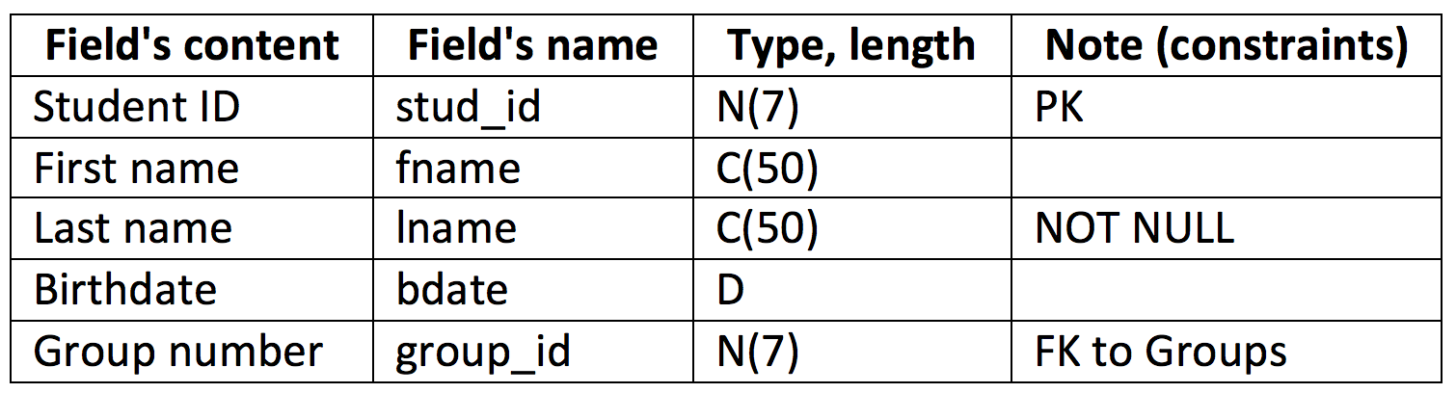

**Upload:** *.doc/ *.pdf

**Materials:**

Lectures 3, 4;

Connolly, Thomas M. Database Systems: A Practical Approach to Design, Implementation, and Management.